tong hop loi oracle

Backup of Oracle RAC (Real Application Cluster) database fails with an error: RMAN-06059: expected archived log not found

Starting backup

current log archived

released channel: t1

RMAN-00571: ===========================================================

RMAN-00569: =============== ERROR MESSAGE STACK FOLLOWS ===============

RMAN-00571: ===========================================================

RMAN-03002: failure of backup command at 14:24:55

RMAN-06059: expected archived log not found, lost of archived log

compromises recoverability

ORA-19625: error identifying file /u02/oradata/scr9/archive/1_1160.dbf

ORA-27037: unable to obtain file status

Linux Error: 2: No such file or directory

Additional information: 3

Solution

RMAN is looking for an archived log that is missing. Running the following command will perform a cross check of the log files and delete the reference to the lost file and will skip that log file during the backup process.

Login to the database server and invoke RMAN

$rman target /

RMAN>change archivelog all crosscheck;

ORA-03113: end-of-file on communication channel cause remove active redo log

Solution

Sqlplus / as sysdba

Startup mount;

Check the latest scn

select GROUP#,THREAD#,STATUS,FIRST_CHANGE#,NEXT_CHANGE# from v$log order by group#;

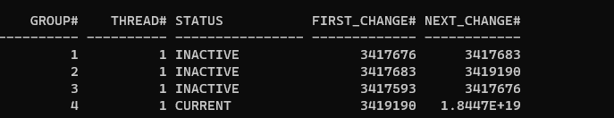

So mean, we lost redolog group 2, pls check in alert log ok

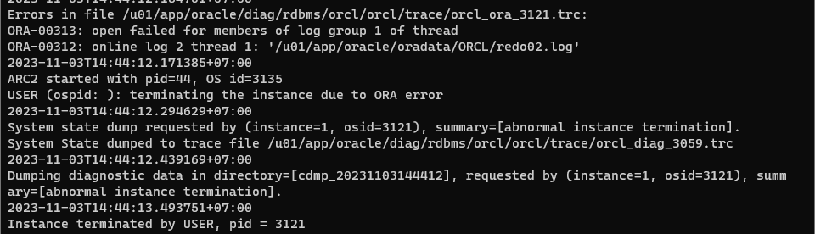

Rman target/

Restore database;

Restore database until 3419190;

After that

Open database with resetlogs ( cuz we restore point in time )

DONE!!!